# UNO GAME

Submitted in partial fulfilment of the requirements of the degree of

Bachelor of Engineering in Artificial Intelligence and Data Science

by

Mayur Pimpude Harsh Rohra Abhijay Sharangdhar Himanshu Sharma

under the guidance of Supervisor : **Mrs. Sangeeta Oswal**



**Department of Artificial Intelligence and Data Science**

**Vivekanand Education Society’s Institute of Technology**

#### 2021-2022

**Department of Artificial Intelligence and Data Science**

**CERTIFICATE**

This is to certify that **Mayur Pimpude, Harsh Rohra, Abhijay Sharangdhar, Himanshu Sharma** of Second Year of Artificial Intelligence and Data Science studying under the University of Mumbai have satisfactorily presented the Mini Project entitled **UNO Game** as a part of the MINI-PROJECT for Semester-III under the guidance of **Mrs. Sangeeta Oswal** in the year 2021-2022.

##### Date: 17 / 12 / 2021



Sangeeta Oswal

(Name and sign) (Name and sign)

Head of Department Supervisor/Guide

### Department of Artificial Intelligence and Data Science

**DECLARATION**

We, ***Mayur Pimpude, Harsh Rohra, Abhijay Sharangdhar, Himanshu Sharma*** from ***D6AD***, declare that this project represents our ideas in our own words without plagiarism and wherever others' ideas or words have been included, we have adequately cited and referenced the original sources.

##### We also declare that we have adhered to all principles of academic honesty and integrity and have not misrepresented or fabricated or falsified any idea/data/fact/source in our project work.

We declare that we have maintained a minimum 75% attendance, as per the University of Mumbai norms.

We understand that any violation of the above will be cause for disciplinary action by the Institute.

Yours Faithfully 1.Mayur Pimpude 2.Harsh Rohra 3.AbhijaySharangdhar 4.Himanshu Sharma

**Acknowledgement**

We are thankful to Our HOD and Vice Principal Dr. Vijaylakshmi Madam for giving us wonderful Topic : Game Development with A.I. in it . As being the first batch of A.I. and D.S. batch in our college we are getting a great experience through A.I. and understand how game development is also a good career option .

Our Mentor Mrs. Sangeeta Oswal ma’am has also given us very good support in our game development . Ma’am also helped us throughout the semester and guided us through the right way and encouragement throughout the work.

Without her guidance our project would not have taken shape.

We sincerely thank all the faculty members in the Department of Artificial Intelligence and Data Science for their advice and counseling from time to time .

# Table of Contents

**Abstract**

**List of Tables List of Figures**

1. **Introduction**
   1. Introduction
   2. Problem Statement
   3. Objectives
   4. Scope
2. **Literature Survey**
   1. Literature/Techniques studied
   2. Papers/Findings
3. **Analysis and Design**
   1. Analysis of the system
   2. Proposed Solutions
   3. Design of the proposed system
4. **Results and Discussion**
5. **Conclusion and Future Work**

**References**

## Abstract:

In this study we examine multiple different algorithms aimed to aid in the card selection process of the popular card game UNO. While most humans take a more trivial approach to card selection this study aims to have an algorithm find the most optimal card solution route in order to maximize win rate while also keeping the time it takes to make this selection to a minimum.

## I ntroduction:

In the game of UNO, the deck consists of 108 cards. These cards are broken up into 4 colors with each color having 19 cards (0 to 9) along with 24 action cards, and 8 wild cards. The aim of this project is to optimize the order in which the cards are played.

Uno is an American card game invented by Merle Robbins in 1971. Then, it became more popular not only in the past but also nowaday because of its enjoyable manner for friends and family. The point of this game is no longer a normal game, it is a humankind of society in the future by connecting humans together. A paper written by Erik D. Demaine titled “The complexity of UNO” found that the single-player version of UNO is NP-complete, but in some cases are in P, while the uncooperative two-player version is in P. This was interpreted that any number of player versions will be in polynomial time solving.

**Game Play**

The game begins with the player immediately left of the dealer, and proceeds in a clockwise direction among the players. During a player’s turn, their goal is to place one of their cards in the discard pile. To do so, the player must place a card from their hand that matches the card on top of the discard pile by number, color, and/or action. If they do not have a card that matches the top of the discard pile, they must draw a card from the draw pile. If they still do not have a card that matches the top of the discard pile, the game moves on to the next player. Alternatively, a player can play a “wild card” which allows them to reset the color on top of the draw pile. Certain cards can alter the game play. If a player plays a reverse card, the direction of gameplay is reversed. If a player plays a skip card, the next player is skipped. If a player plays a draw card, the next player must draw a card from the draw pile. The objective of the game is to be the first player to play all of your cards. The game ends once any player has played all their cards and thus has no cards remaining in their hand.

**Formal Problem Statement**

Given a set of N cards in a hand, label each with a distinct counting number from the set

S = {0, …, N-1}. For X being the top discarded card, find a permutation P of the cards in S that minimizes the cost, given by the function below, of the permutation with the start of the

permutation being X.



**Literature Survey**

#### Literature learning:

#### PAPER FINDINGS:

* Uno (Card Game).” Wikipedia, Wikimedia Foundation, 15 Apr. 20

From these we found some important rules on how to play UNO game, what are penalties , Inappropriate moves .

* Research paper of stanford over reinforcement learning in UNO

This research paper is one of the vital paper that helped us understand various aspect from the game to many things that we will look like we got to know in depth about Q learning and how to relate UNO game with the algorithm and what calculations are needed prior for these . Also got a comparison between Q learning and other A.I. based algorithm like deepSARSA . In this research paper .There is also research telling us that how second move after the start of a game is more beneficial for the computer to win .

**APPROACH**

The problem was decided to be tackled by reinforcement learning.RL is a machine learning method.In this method, rewards and punishments are given for desirable and undesirable results respectively. A reinforcement learning agent is able to perceive and interpret its environment, take actions and learn through trial and error.The major components of RL are state,reward,environment,action to be taken,and the agent.

Thus,if the agent plays a card which results in an unfavourable outcome for itself,it will be reprimanded.And if it results in a positive scenario,it will earn a reward.A table is maintained where the information from played games is recorded.Thus, after playing a considerable number of games,the agent will be able to win easily.

### DESIGN:

UNO GAME will be designed using or python. We have many functions in the game as it's a card game . So some of the functions are creating a deck of card then shuffle deck ,add player and its name, distribute the cards ,count cards , read a card.

For Computer to understand that which card it needs to play and which card is matching with the card on table from other person we will pass string to each card like B7 i.e. Blue color card and 7 as number of card and then the computer will check whether it has any of these two condition matching in its set of cards. If yes then it will play the card otherwise it will pass the chance to the next player with increment of a card for a deck .

#### GUI:

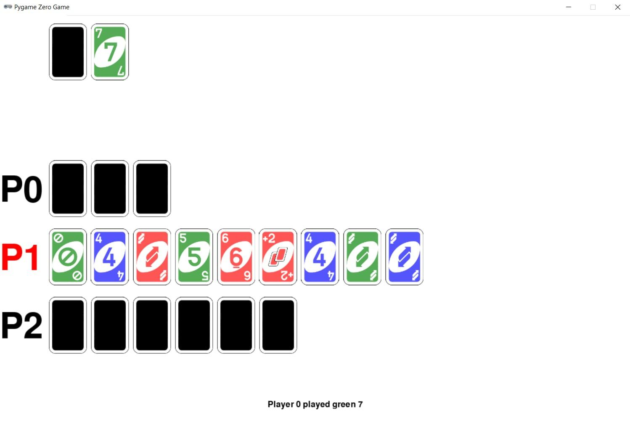

In the above image P1 player represents the User, P0 and P2 player represents the Computer.

**R ESULT & DISCUSSION**

In this semester we have partially implemented our game and learned about A.I. component we are going to use in the future which will be integrated in our game.

#### CONCLUSION:

In conclusion we have understood the depth of game implementation and Reinforcement learning . In this semester we understood how to make computer understand how to play the game by the rules and understand which card it needs to play.Card games are a powerful framework for decision-making algorithms, since they involve considerable uncertainty (e.g. uncertainty over what card might be drawn, uncertainty over others’ hands, etc.) and have clear rules around legal actions and defining rewards.

#### FUTURE WORK:

##### Learning and applying RL with uno code.

**REFERENCE:**

Uno (Card Game).” Wikipedia, Wikimedia Foundation, 15 Apr. 20:

<https://en.wikipedia.org/wiki/Uno_(card_game)>

Java UNO Program/Algo:

[https://codereview.stackexchange.com/questions/208644/cards-shufﬂing-and-](https://codereview.stackexchange.com/questions/208644/cards-shuffling-and-dealing-program)

[dealing-program](https://codereview.stackexchange.com/questions/208644/cards-shuffling-and-dealing-program)

Research paper of stanford over reinforcement learning in UNO:

[https://web.stanford.edu/class/aa228/reports/2020/ﬁnal79.pdf](https://web.stanford.edu/class/aa228/reports/2020/final79.pdf)

UNO game project:

[http://people.uncw.edu/tagliarinig/Courses/380/S2019%20papers%20and%20](http://people.uncw.edu/tagliarinig/Courses/380/S2019%20papers%20and%20presentations/Flash-UNO%20Opt%20Deforge%20Gray%20Tran/UNO%20Final%20Paper.pdf)

[presentations/Flash-UNO%20Opt%20Deforge%20Gray%20Tran/UNO%20Fin](http://people.uncw.edu/tagliarinig/Courses/380/S2019%20papers%20and%20presentations/Flash-UNO%20Opt%20Deforge%20Gray%20Tran/UNO%20Final%20Paper.pdf)

[al%20Paper.pdf](http://people.uncw.edu/tagliarinig/Courses/380/S2019%20papers%20and%20presentations/Flash-UNO%20Opt%20Deforge%20Gray%20Tran/UNO%20Final%20Paper.pdf)

Reinforcement learning in UNO :

[https://towardsdatascience.com/tackling-uno-card-game-with-reinfo](https://towardsdatascience.com/tackling-uno-card-game-with-reinforcement-learning-fad2fc19355c)

[rcement-learning-fad2fc19355c](https://towardsdatascience.com/tackling-uno-card-game-with-reinforcement-learning-fad2fc19355c)